

EBAY CONTROLLER TEST DATA SHEET

P/N: AHU-L (47) 413-8005-1 Date: 08/03/2018 Time: 14:21

S/N: 221 Tested by: Elie Talias

Hardware Rev: BLDC_60A_V6 Approved by: Elie Talias

Software Rev: 5.3.9

Equipments Used

Equipments Model No Serial No

Power Supply

Digital Multimeter

CAN Interface

Resistance Decade Box

PC

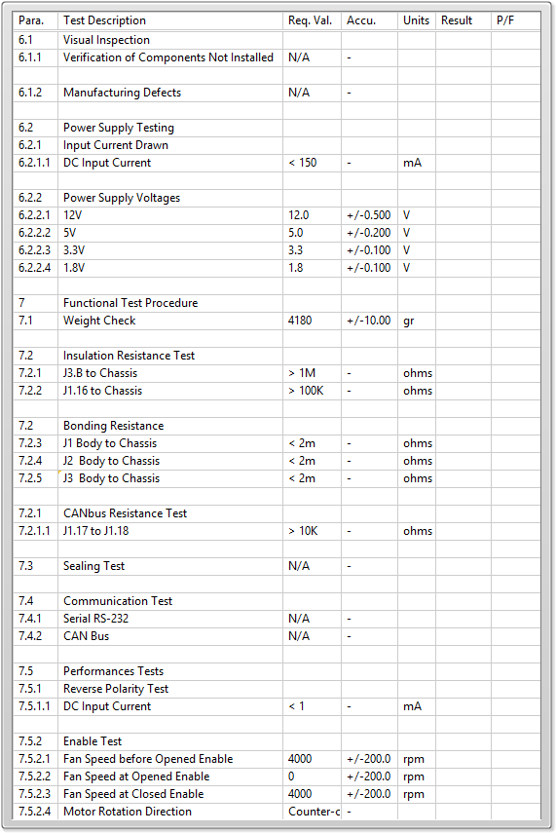

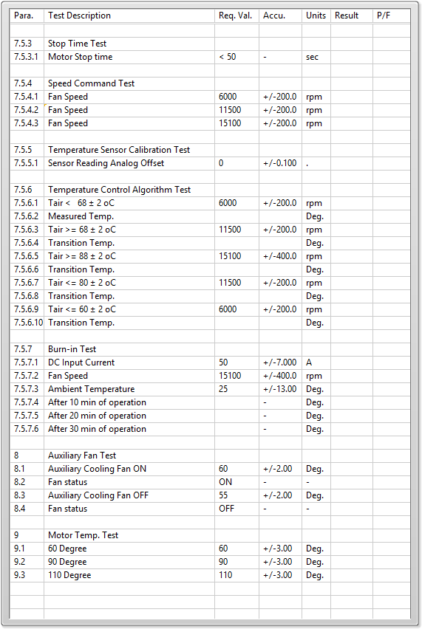

General result:

Test-Operator:____ Elie Talias_________ Q.A.:__________________________